Universal process transmitter:
Robust and highly accurate

Klingenberg, April 2014.
With the UPT-2X, WIKA has brought a new process transmitter to market. It is a highly accurate all-purpose instrument with a robust design and an on-site display.

The compact plastic housing of the UPT-2X, depending on requirements, is fitted with a measuring sensor between 0 ... 400 mbar and 0 ... 1,000 bar. The measuring ranges are freely scaleable, with a maximum recommended turndown of 20:1. The transmitter is easy to work with. It communicates via the latest HART® standard (v7). With its adjustable display head, this instrument can suit almost any mounting situation. Thanks to its 60 mm display, the values are always easily readable from a distance.

As well as being suitable for almost any application, the UPT-2X is cost-effective. Tool-free handling saves time and the high long-term stability ensures low maintenance costs.

Number of characters: 920
Key word: UPT-2X

Manufacturer:
WIKA Alexander Wiegand SE & Co. KG
Alexander-Wiegand-Straße 30
63911 Klingenberg/Germany
Tel. +49 9372 132-0
Fax: +49 9372 132-406
vertrieb@wika.com
www.wika.com

WIKA company photograph:
WIKA process transmitter UPT-2X

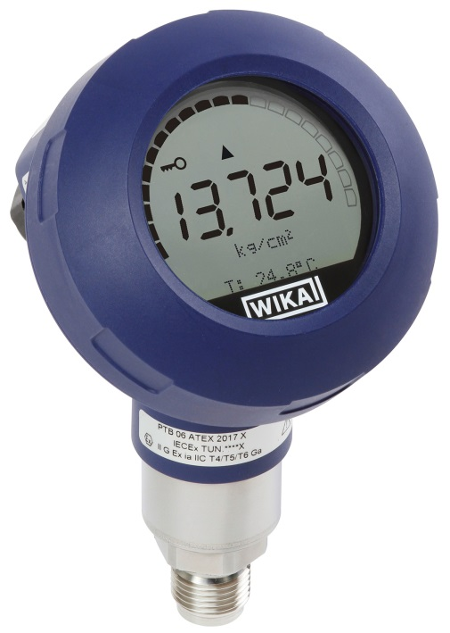

Edited by:
WIKA Alexander Wiegand SE & Co. KG
André Habel Nunes
Marketing Services
Alexander-Wiegand-Straße 30
63911 Klingenberg/Germany
Tel. +49 9372 132-8010
Fax: +49 9372 132-8008010
andre.habel-nunes@wika.com
www.wika.com

WIKA press release 04/2014

